33.40: 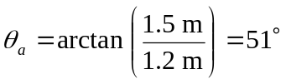
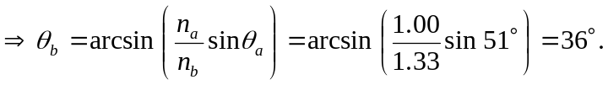
So the distance along the bottom of the pool from directly below where the light enters to where it hits the bottom is:

